**LAB 1 – COAL LAB 1**

**Set up**

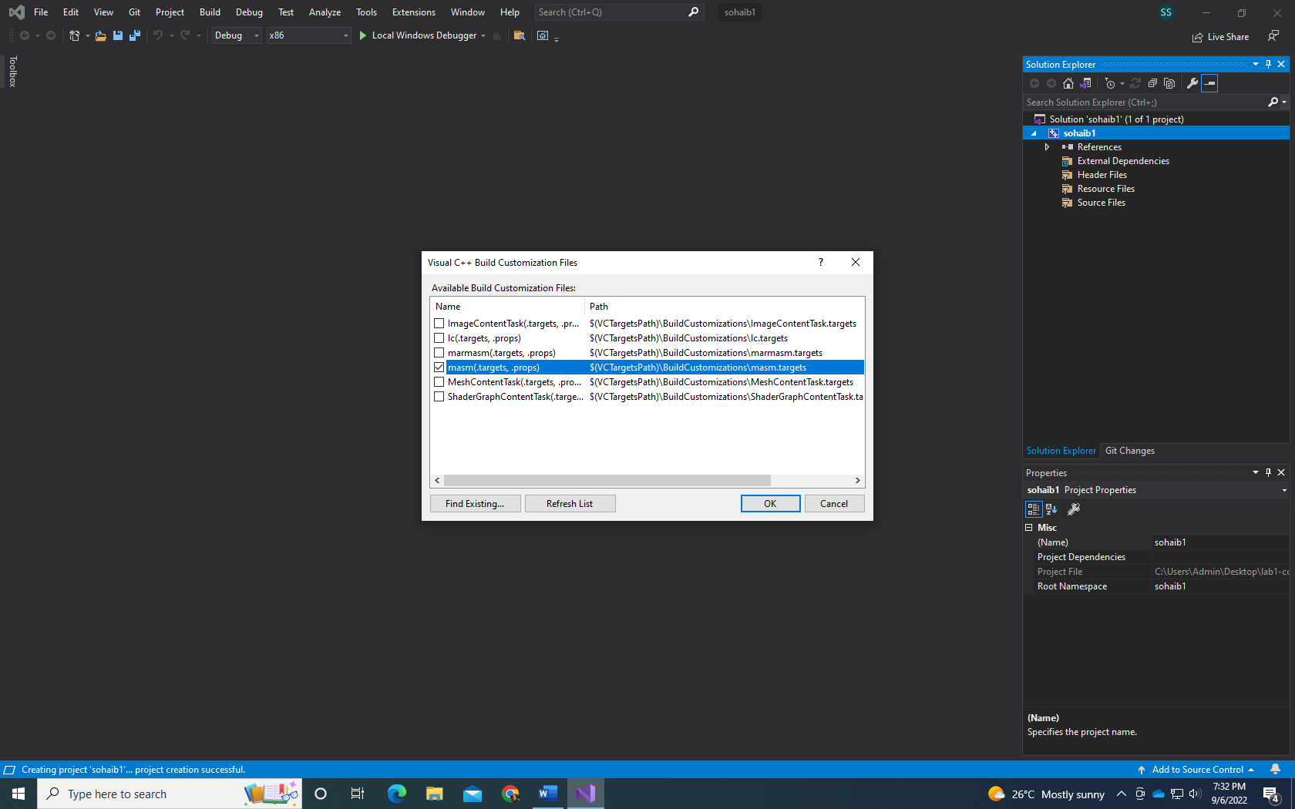

**Debugging task:**



